Model: | Renova Nr. 1 Comfort Wash-down WC, without flushing rim 4,5/6 l, wall-hung 700 mm projection
Model No. | 208570

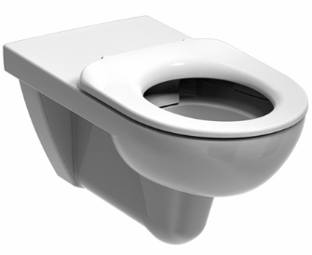 | 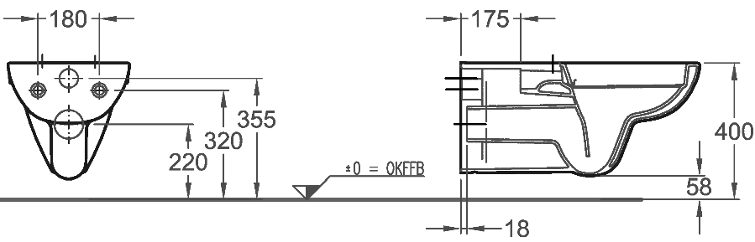 | 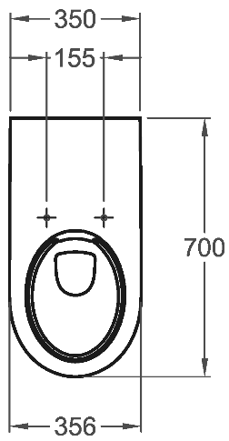

Washdown WC, 4.5/6l
Rimless
CE, EN 997 - CL1 5A + 6AC, EN33
Wall-hung with 70 cm projection
Made of sanitary ware porcelain
CE-marked
For in-wall cabinet
DIN 18040
Particularly suitable for use by wheelchair users.

Brand: KERAMAG
Model: Renova Nr. 1
Model no.: 208570
Size: Width: 350 mm, Depth: 700 mm
Fastening: Threaded rods M 12
Outlet: horizontal

Optional:
With permanently fired KeraTect(r) glaze, free of pores, surface roughness value in accordance with DIN 4768-ISO 4287 Ra < 0.01 µm (Colour code 600)

Can be combined with:
WC seat with continuous stainless steel hinge shaft 578510

